Russky Bridge (Russia)
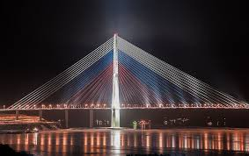

Introduction
The Russky Bridge (Russian: Русский мост) is a cable-stayed bridge in Vladivostok, Russia, connecting Russky Island and the mainland. Completed in 2012, it gained international attention for its impressive span and elegant design.

Key Facts
Location: Vladivostok, Primorsky Krai, Russia (connecting Russky Island to the mainland)
Opened: 2012 (officially opened in July 2012)
Type: Cable-stayed bridge
Main Span: 1,104 meters (approx.) — among the longest cable-stayed spans in the world
Total Length: Approximately 3,100 meters (including approaches)
Tower Height: 321 meters (pylon height)
Designer/Engineer: Designed by Russian and international engineering teams
Purpose: To improve transport connections to Russky Island and support development, including for the 2012 APEC summit

Construction and Design
Russky Bridge is a striking example of modern cable-stayed bridge engineering. Its single-span configuration for the main span and tall central pylons create both functional strength and visual impact. Construction required advanced materials and techniques to handle the region's winds, seismic considerations, and marine environment.

Historical Context and Significance
The bridge was built as part of infrastructure improvements in Vladivostok, notably to provide easy access to Russky Island ahead of the 2012 APEC summit, which was hosted on the island. It symbolizes regional development and has become an important local landmark and attraction.

Visitor Information
Visitors to Vladivostok often view the bridge from vantage points along the coastline. While pedestrian access across the entire span may be restricted, nearby viewpoints and illumination at night make it a popular subject for photographers.

Notes
This document provides an overview based on widely-known facts about Russky Bridge. For precise technical specifications, engineering reports, or historical documents, consult official sources or engineering publications.

Document generated: 2025-10-20 07:16:55 UTC

